1.Open the Power BI Desktop application on your computer.

2.In Power BI Desktop, navigate to the "Home" tab located at the top of the interface.

3. Click on "Get Data" in the ribbon menu to access the "Get Data" window.

4.A variety of data sources such as Excel, CSV, SQL Server, or Web will be displayed. For this example, select the "Folder" option.

5. Locate and select the folder you wish to import by browsing through your files.

6. After selecting the folder, click on the "Transform Data" button to edit the data in Power BI.

7. Use the "Remove Column" option to eliminate any columns containing empty values.

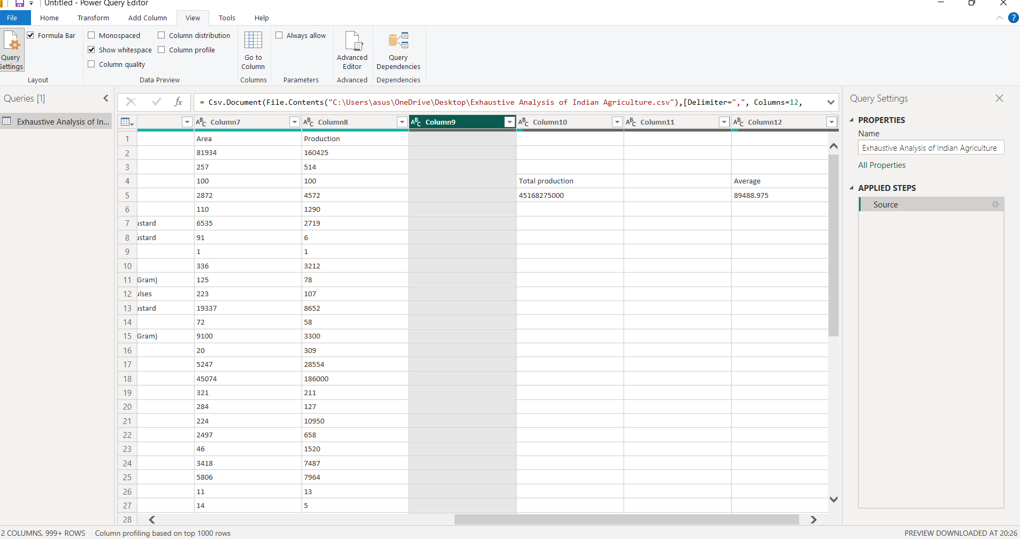

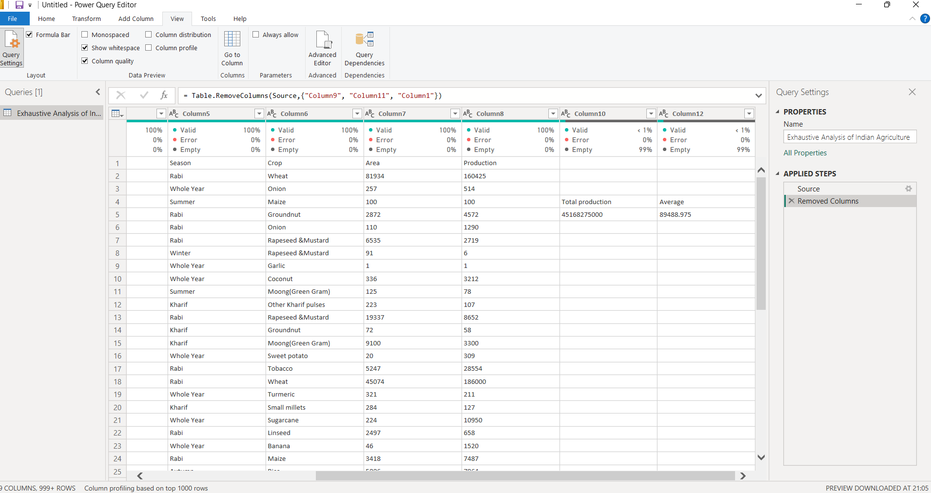

8) Check the Column Quality using View option :

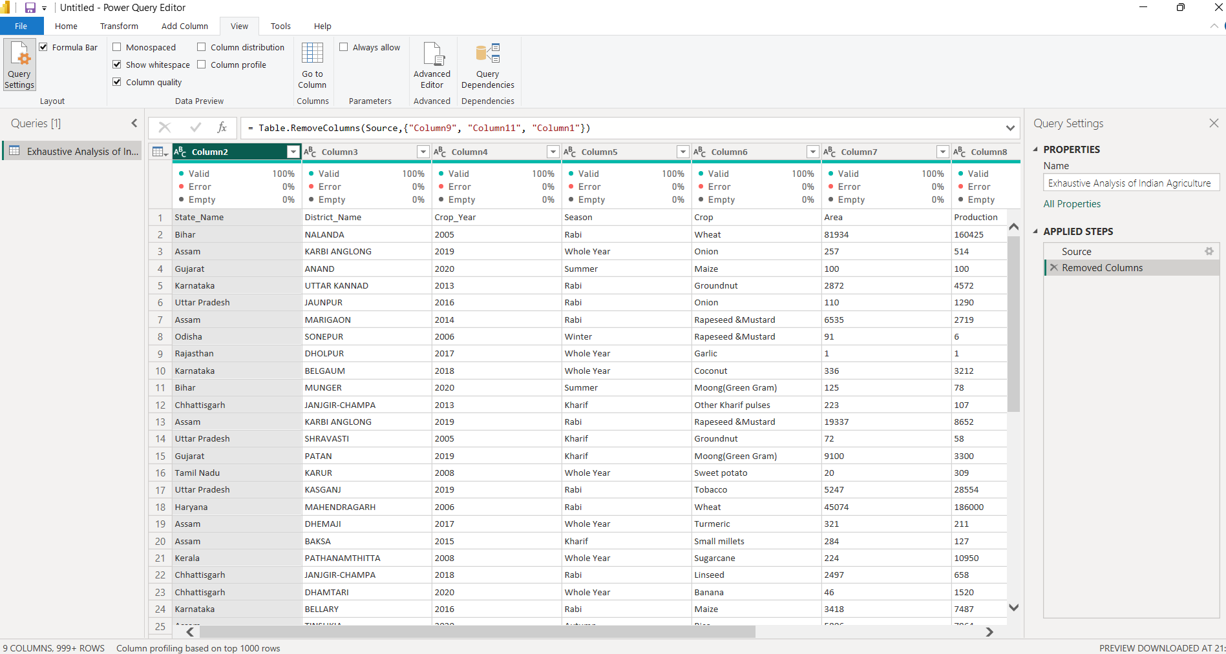

9) Once done, click "Close & Apply" to load the data into Power BI.

